***Project - 02***

***In this project, we will learn how to create a static website and deploy it using AWS services. A static website is a site that consists of HTML, CSS, and JavaScript files, and it doesn't require server-side processing or a database.***

Documentation For Static Website:-

**Step 1: Log in to AWS Management Console:**

* 1. Open [AWS Management Console](https://aws.amazon.com/).

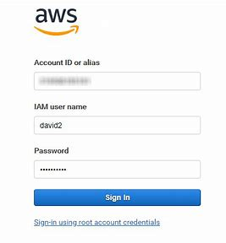

### Step 2: Create an S3 Bucket

**Navigate to S3 Service:**

* 1. In the search bar, type S3 and select the S3 service.

**Create a New Bucket:**

* 1. Click on Create bucket.

2. Provide a unique bucket name (e.g., my-website-bucket).

3. Choose the appropriate AWS region.

4. Leave the default settings and click Create bucket.

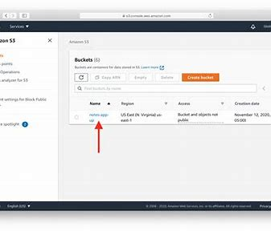

### **Step 3: Upload Your Website Files to S3**

1. **Select Your Bucket:**
2. Click on the bucket name you created.

**Upload Files:**

1. Click on Upload.
2. Drag and drop your website files into the S3 bucket.
3. Click Upload to start the upload process.

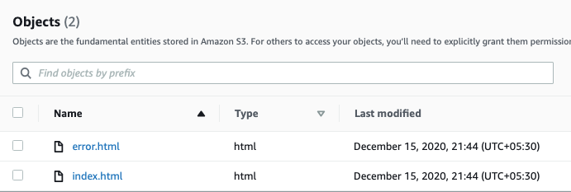

### Step 4: Configure the S3 Bucket for Static Website Hosting

1. **Enable Static Website Hosting:**
2. Go to the Properties tab of your S3 bucket.
3. Scroll down to the Static website hosting section.
4. Select Use this bucket to host a website..

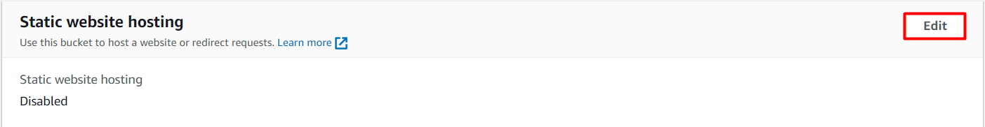

* 1. Specify the index document (e.g., index.html).
  2. Specify the error document (e.g., error.html) if you have one.
  3. Click Save

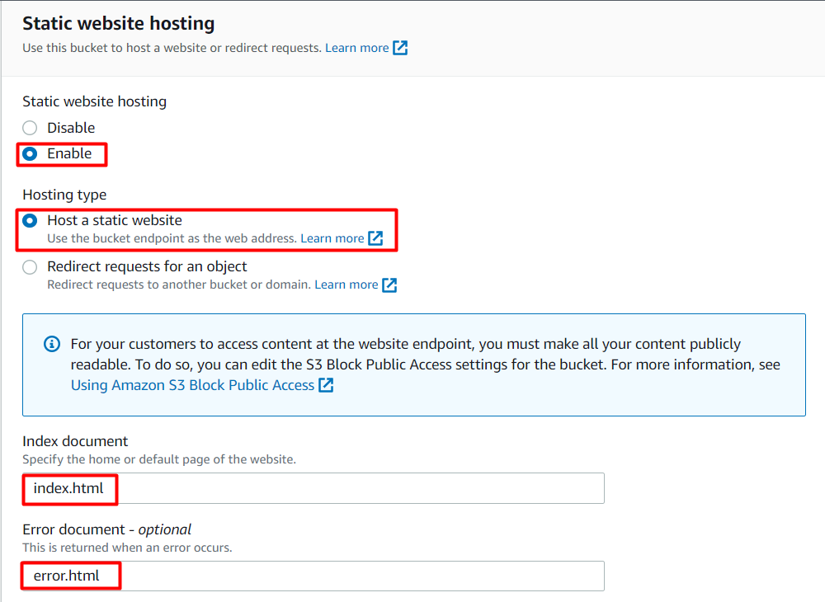

### Step 5: Set Bucket Policy to Allow Public Access

1. **Bucket Permissions:**
2. Go to the Permissions tab of your S3 bucket.
3. Click on Bucket Policy.

**2. Add a Bucket Policy:**

1. Use the following bucket policy to allow public read access:

json

Copy code

{

"Version": "2012-10-17",

"Statement": [

{

"Effect": "Allow",

"Principal": "*",

"Action": "s3:GetObject",

"Resource": "arn:aws:s3:::my-website-bucket/*"

}

]}

1. Replace my-website-bucket with your actual bucket name.
2. Click Save.

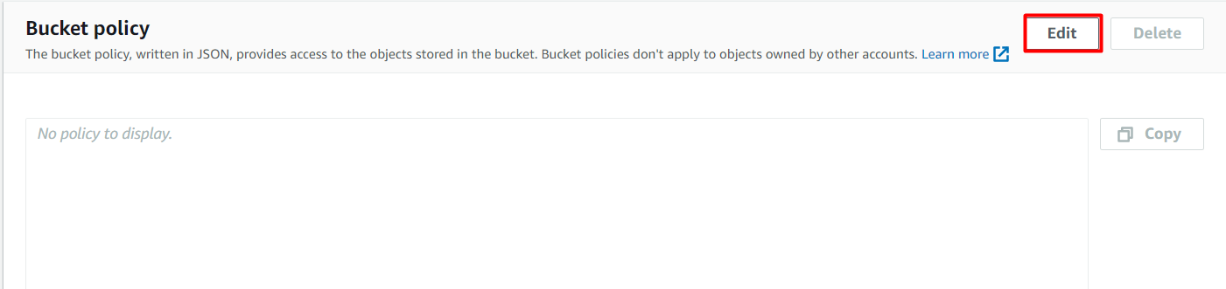

### Step 6: Access Your Static Website

1. **Obtain the Website URL:**
2. Go to the Properties tab.
3. In the Static website hosting section, note the Endpoint URL.

**2 Visit Your Website:**

1. Open a web browser and navigate to the endpoint URL to see your static website live.

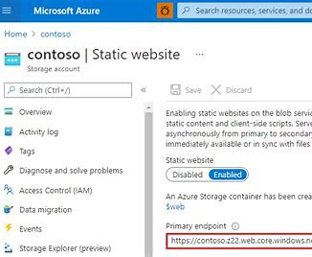

### Step 7: Run This URL New Tab in Chrome.

1. Finally complete your work and show your created website.

***Thank You***

SHUBHAM SHARMA

*shubhamsharma01082005@gmail.com*